
PROJECT X: ATTENDANCE TRACKING SYSTEM
Ranel Pagantian
Darvey Quimbo
Gella Marie Lcoginsa

A BSIT Emerging Technology Project Submitted to the Faculty of Computing, Engineering and Technology of Davao Oriental State University in Partial Fulfillment of the Requirements for the Degree

BACHELOR OF SCIENCE IN INFORMATION AND TECHNOLOGY

MAY 2025

1. Introduction

1.1 Purpose
This document provides the high-level design for the Attendance Tracking System intended to automate attendance collection and reporting processes for Admin, Instructors and Students.

1.2 Scope
The system supports user management, barcode-based attendance tracking, security enforcement, and report generation, with a focus on cloud-based deployment and scalability.

1.3 References
Elicitation Requirements for the Attendance Tracker (Project-X 01. Requirements)

2. System Overview
The Attendance Tracking System allows instructors to take attendance using registered devices via barcode scanning. It supports administrative functions such as managing users, viewing attendance data, and generating reports while enforcing strong security practices.

3. Architectural Design

3.1 Architecture Diagram
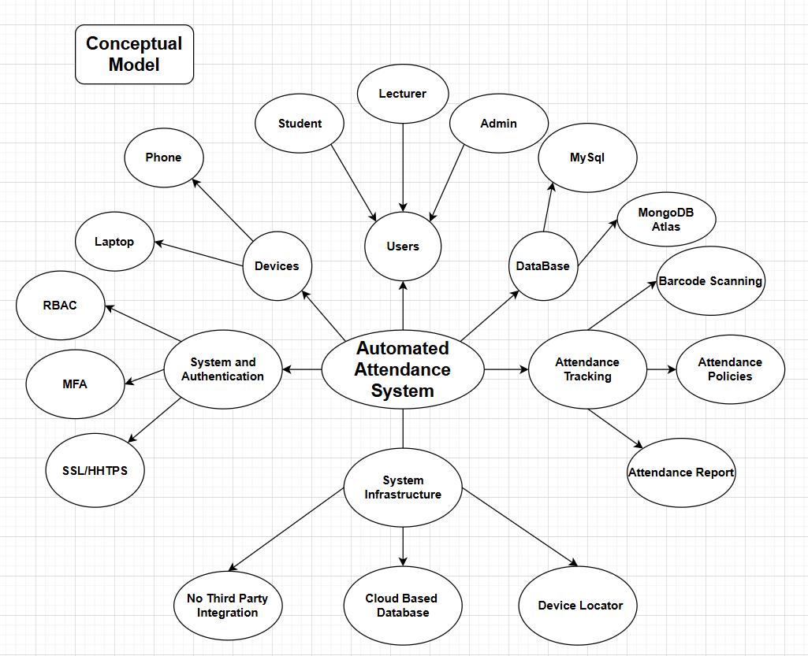
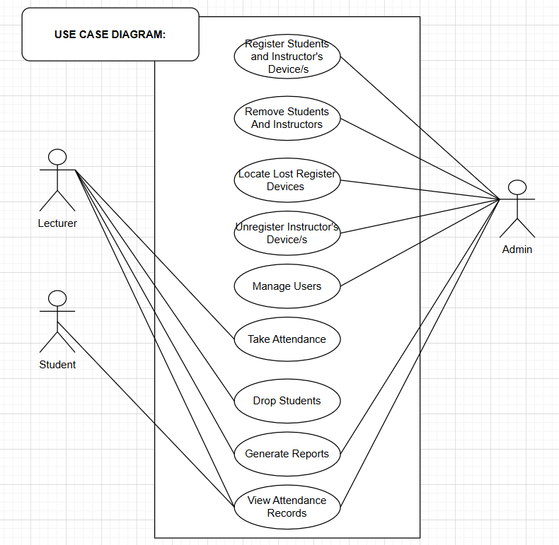

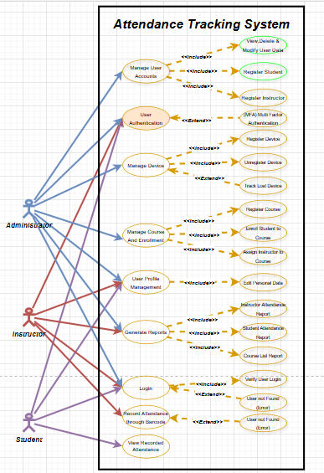

3.2 Architectural Style
Modular Web Application
RESTful Microservices
Cloud-based deployment with frontend, backend, and database services

3.3 Technology Stack
Layer | Technology
Frontend | React or Angular
Backend | Node.js or Django REST Framework
Database | MongoDB Atlas or MySQL (Cloud)
Authentication | JWT, MFA
Deployment | AWS / Azure, Docker, NGINX

4. Module/Component Design
Component | Description | Responsibilities | Dependencies
User Management | Handles registration/removal of users | Register/unregister students/instructors | DB, Auth service
Attendance Module | Barcode-based attendance logging | Scan IDs, drop students after 3 absences | Device registry, DB
Auth Service | Login and security features | MFA, RBAC | Identity provider
Reporting Module | Attendance data visualization & export | Generate reports for admins | DB, RBAC
Device Manager | Tracks and manages registered devices | Lost device lookup | Device registry

5. Data Design

5.1 High-Level Data Model
Entity | Attributes
Student | ID, Name, Program, Year, Faculty
Instructor | ID, Name, Courses, Registered Devices
Attendance | Student ID, Course ID, Timestamp, Status
Device | Device ID, Owner ID, Type, Registered Status

5.2 Data Flow
1. Admin Manage the System Add Users(Lecturer, Student)
- Instructor logs in with MFA
3. Selects course and scans student IDs
4. Attendance data is recorded and stored
5. Admins generate reports from aggregated data

6. API Design

6.1 External APIs

6.2 Internal APIs (REST)
Endpoint | Method | Description
/login | POST | MFA login
/students/register | POST | Register new student
/attendance/scan | POST | Log scanned attendance
/reports/attendance | GET | Generate attendance report

7. Security Considerations
RBAC to control access to features
Admin-controlled encryption for sensitive data
Multi-Factor Authentication for instructor logins
All communication secured via HTTPS and SSL protocols

8. Scalability & Performance
Cloud-based deployment supports auto-scaling
Load balancing for handling high request volumes
Caching for frequently accessed attendance records
Use of NoSQL (MongoDB) or optimized MySQL indexing for fast queries

9. Deployment Architecture

9.1 Environments
Development
Staging
Production

9.2 Deployment Strategy
Docker containers for all services
CI/CD pipelines using GitHub Actions / GitLab CI
Monitoring with Prometheus and logging with ELK Stack

10. Fault Tolerance & Reliability
Device registry to detect lost devices
Database backups and disaster recovery plan
Failover support on cloud infrastructur

11. Limitations and Assumptions
Assumes all Students have compatible scanning devices
No API support for university-wide system integration
All attendance must be taken via barcode; no manual override mentioned

12. Glossary
Term | Definition
MFA | Multi-Factor Authentication
RBAC | Role-Based Access Control
SSL | Secure Sockets Layer
API | Application Programming Interface

Appendices

Frontend:
Landing page:
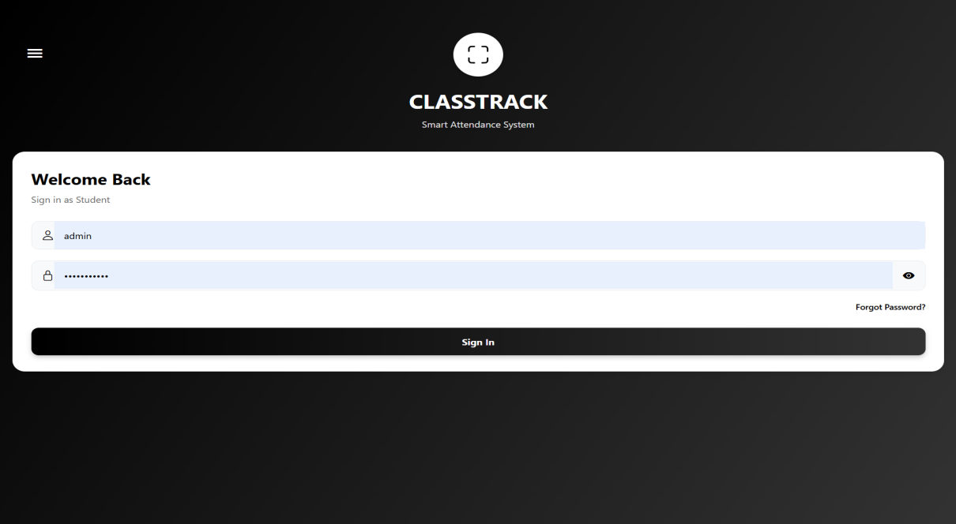

Admin Dashboard Page

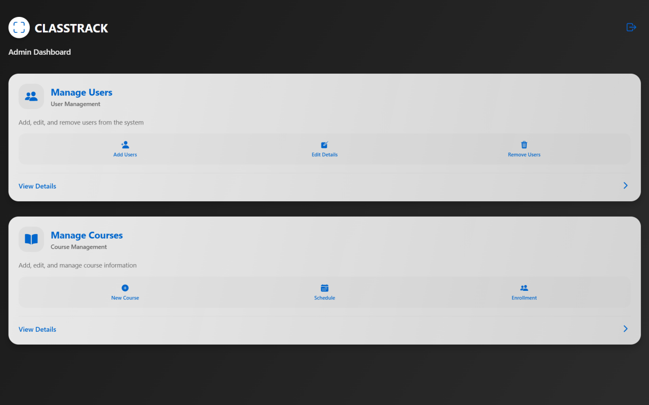

Manage Users page
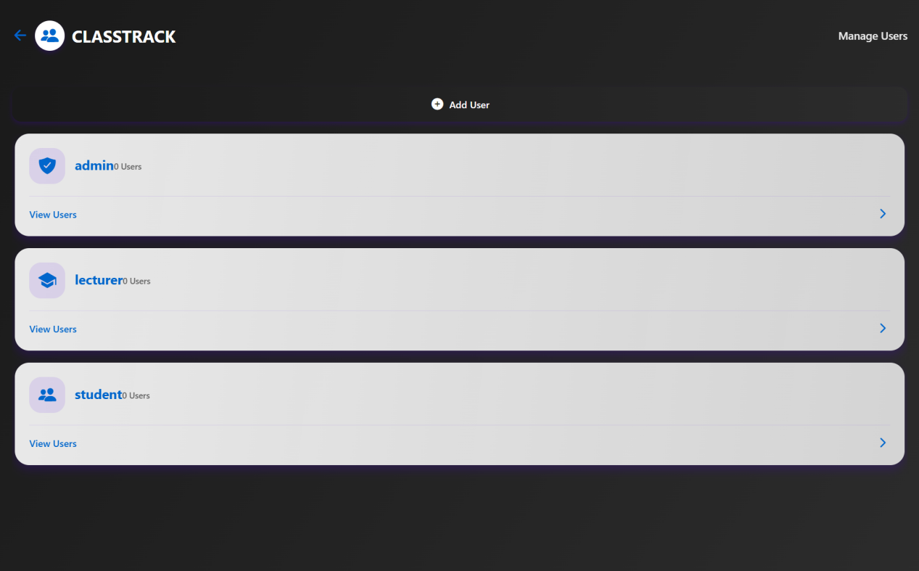

Add new Users Page

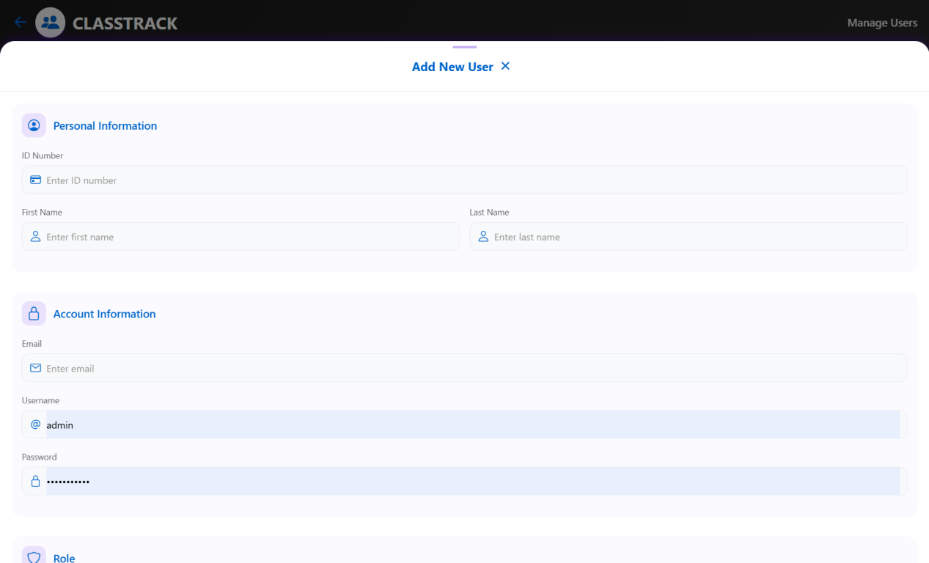

Add Courses

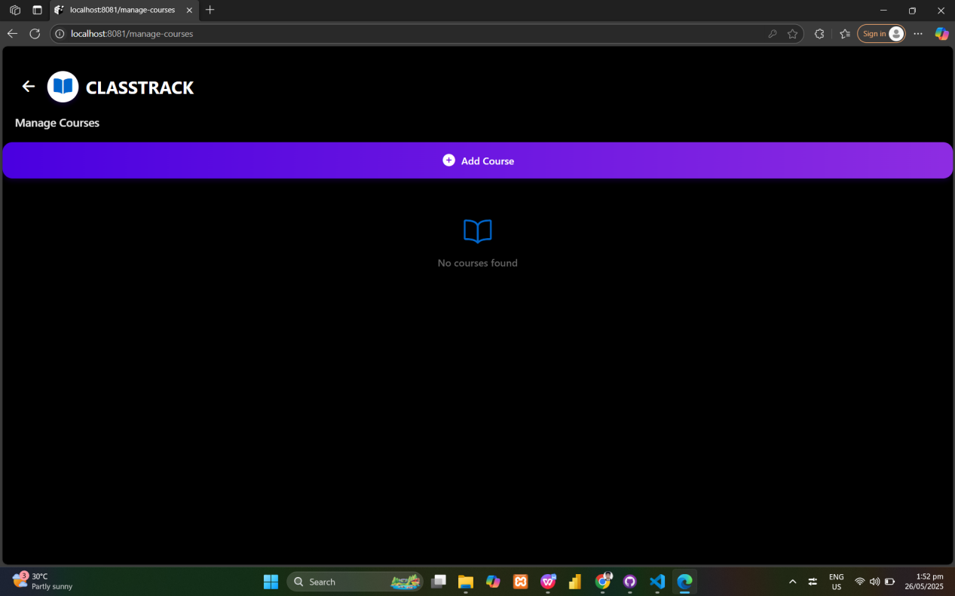
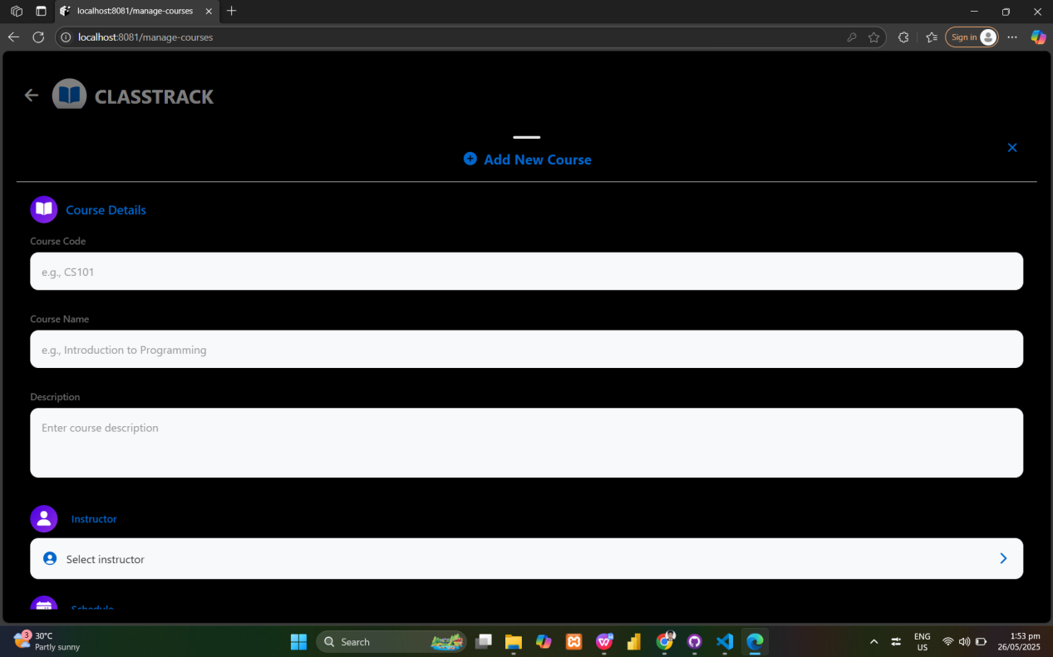

Lecturer page
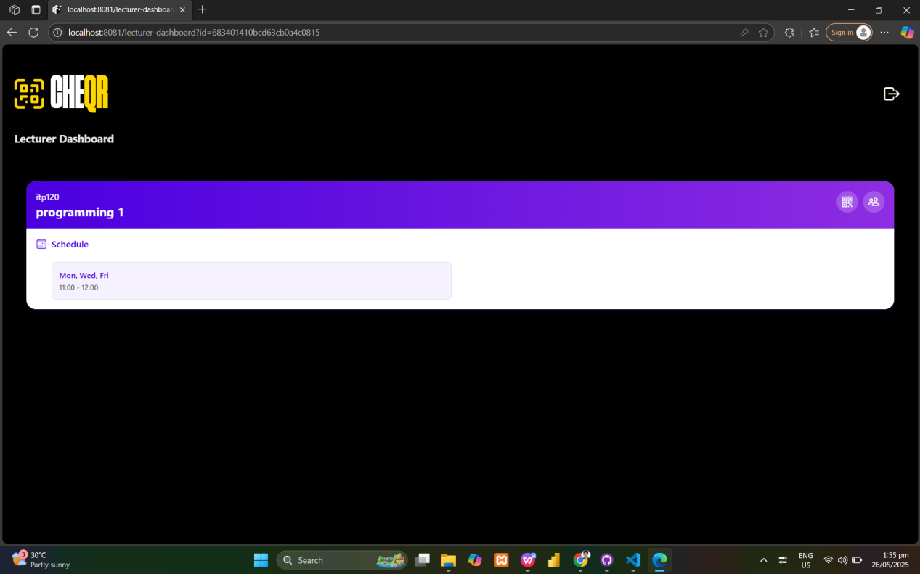

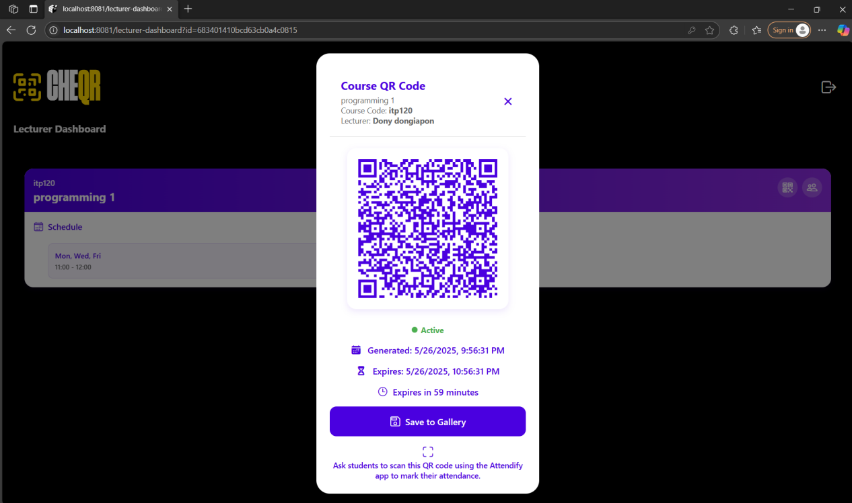

Backend:
Users Table

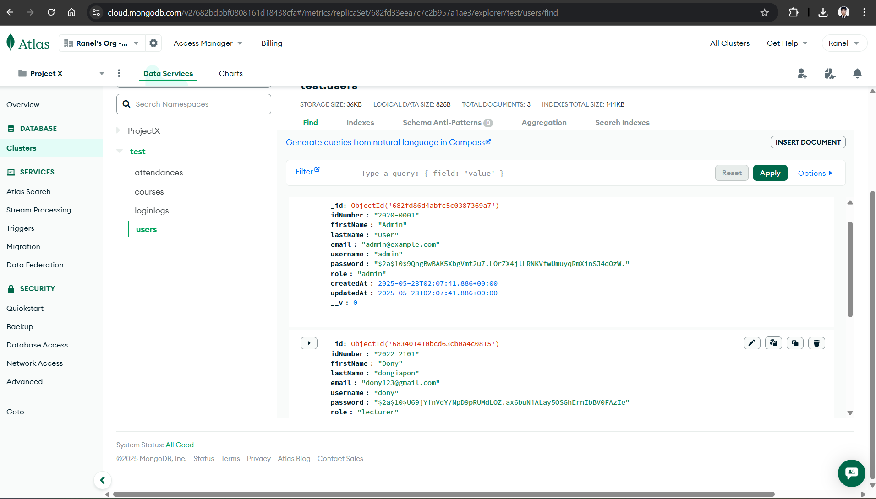

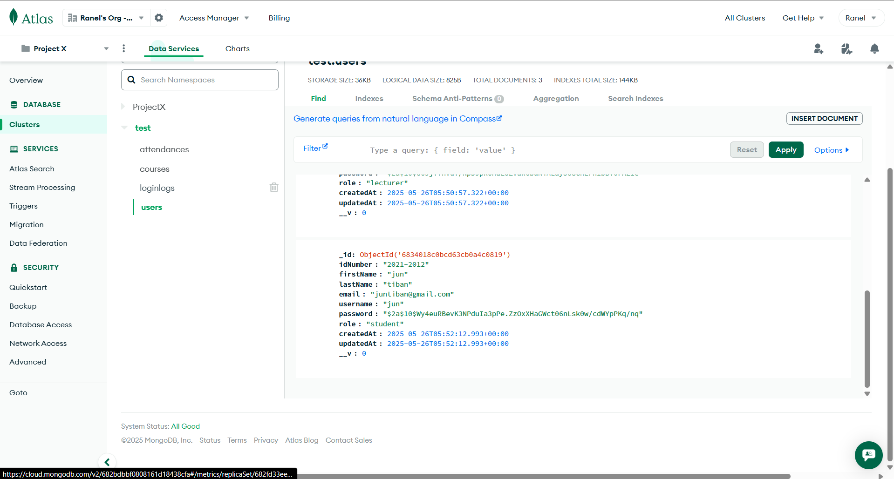
LoginLogs Table
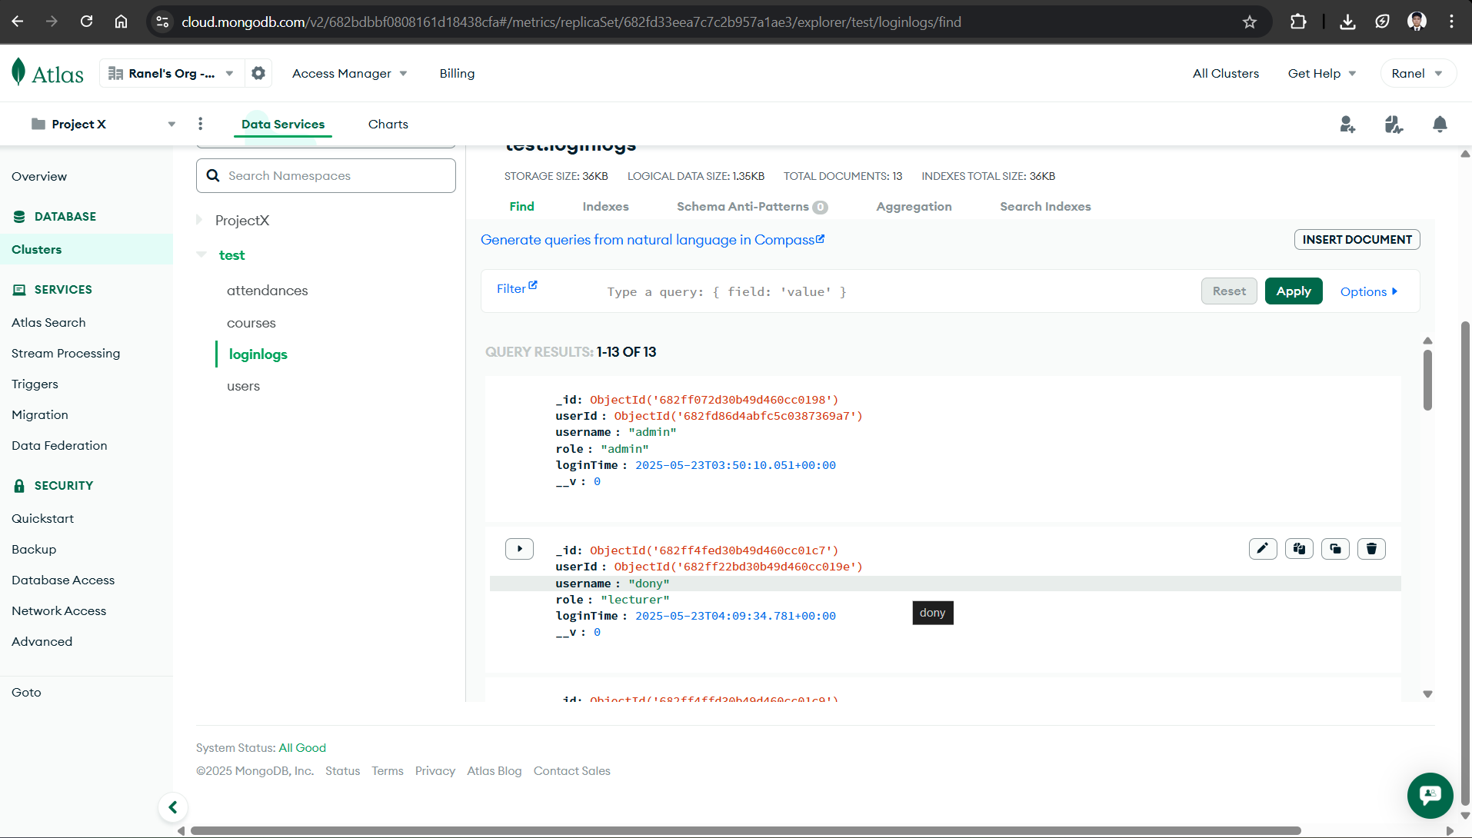
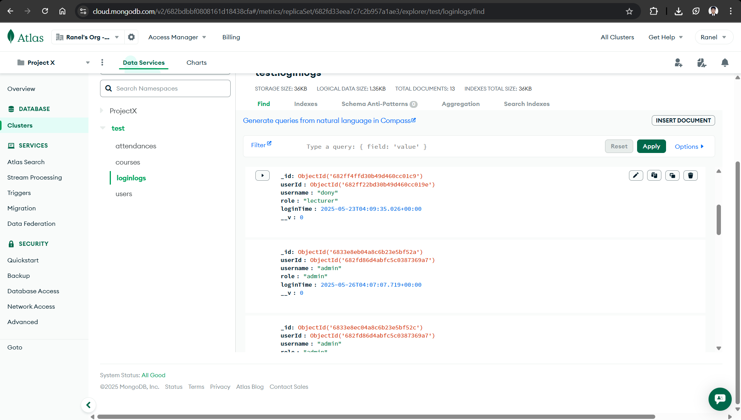
Courses Table
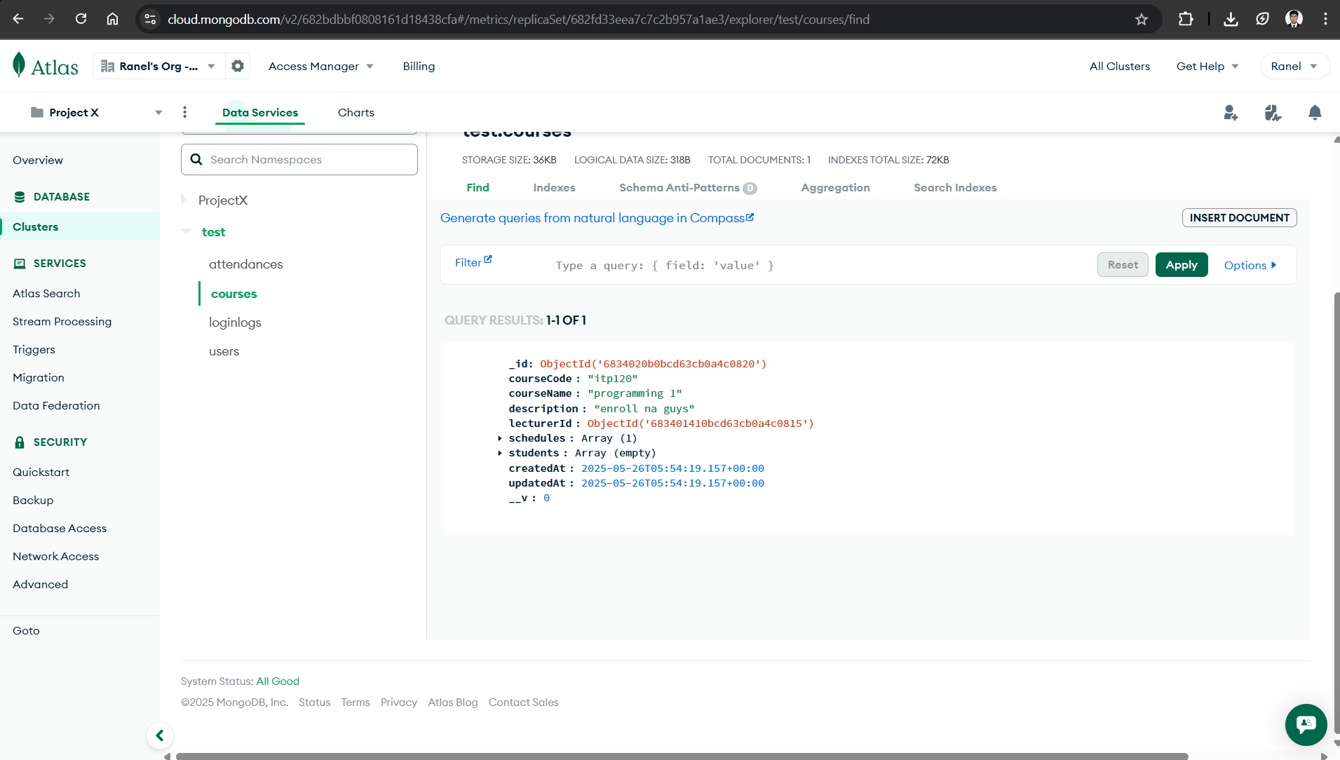

Attendances Table
